**Union Elementary School**

**School Improvement Plan**

**2024-2025**

**Blake Keown, Principal**

PCSD VISION

PCSD MISSION

***The vision of the Paulding County School System is to prepare ALL students for success today and tomorrow.***

***Engage. Inspire. Prepare.***

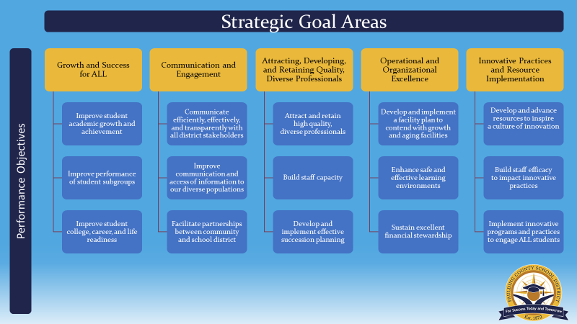

SCHOOL MISSION & VISION

**Our Mission**

The mission of Union Elementary is to create and foster a nurturing environment that reaches a high level of academic success and inspires community support.

**Our Vision**

The vision of Union Elementary is to build positive relationships with our students that encourage and motivate them to have values, set and fulfill goals, as well as graduate and experience future success.

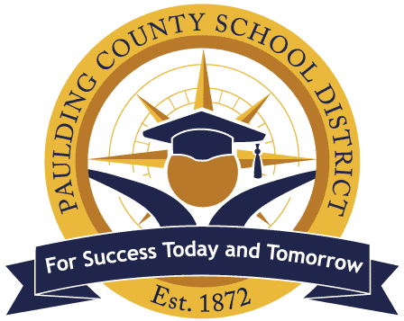

|  |  |  |  |  |  |
| --- | --- | --- | --- | --- | --- |
| ***Union Elementary School Improvement Action Plan***  ***SMART Goal 1:*** *The 23-24 cohort of 3rd and 4th grade students scoring Level 3 or 4 on GMAS Extended Writing Task 1 will increase from 27.82% to 46.09% on 24-25 GMAS Extended Writing Task 1.*  *[By moving a ¼ (21 students) of our total Level 1 and 2 students (83), 46.09% of 4th and 5th grade students (53 students) will be at a Level 3 or 4.]*  *SMART Goal 2: Third grade students scoring a Level 3 or 4 will increase from 12.28% on 23-24 GMAS Extended Writing Task 1 to 30.00% on the GMAS Extended Writing Task 1, which will result in 18 of the 62 incoming 3rd graders scoring a Level 3 or 4 on GMAS Extended Writing Task 1.* | | | | | |
| **Strategic Goal Area** | **Initiatives/Action Steps** | **Process Goals**  **(Guide your Action Steps – benchmarks along the way)** | **Person(s)**  **Responsible** | **Monitoring** | |
| **Implementation**  **(Artifacts/Evidence)** | **Effectiveness**  **(Formative Data)** |
| **Strategic Goal:**  Growth and Success for ALL | Use evidence-based writing strategies daily using Bookworms and WriteScore resources. Strategies are referenced in the “Writing Lesson Observation & Feedback Tool”. | - During vertical and grade level PLCs, teachers will analyze WriteScore and GMAS assessment data, along with student work samples, to conference daily with students and determine instructional next steps  -During grade level and vertical PLCs, plan use of supplemental WriteScore lessons to accompany Bookworms Genre Based Writing  - Grade level PLCs collaboratively score a minimum of one writing sample per genre | Teachers, Administration | -School Leaders hold data days to facilitate data analysis for both WriteScore cycles using specific protocols  -School Leaders facilitate GMAS data analysis using domain and writing data 2xs per year  - Lesson plans guided by district provided Bookworms_WriteScore ELA samples pacing  - Grade level PLCs meet weekly, and agendas include a specific time for planning writing instruction and collaborative scoring | -WriteScore data (2 times annually)  - GMAS domain and writing scores  -Administration will conduct writing-focused classroom observations monthly  -Students can understand and verbalize next steps and set goals towards improving their writing |

***Union Elementary’s Professional Learning Plan***

| **Professional Learning Strategy/Support**  (**Should be connected to effectiveness monitoring of action steps in the SIP**) | **Audience** | **Presenter** | **Timeline** | **Monitoring** | |
| --- | --- | --- | --- | --- | --- |
| **Implementation** | **Effectiveness** |
| Professional learning for 3rd grade teachers on transitioning students from 2nd to 3rd grade writing. | 3rd Grade Teachers | Kim Merrell | Pre-planning | Teachers will deliver lessons that provide developmentally appropriate transitions from 2nd to 3rd grade | **-**Lesson plans include integration of WriteScore and Bookworms lessons per genre |
| Training on Georgia Milestones’ ELA domains to prepare teachers for a data-informed approach in making instructional decisions and customizing teaching methods to meet students' specific needs. | 3-5 Teachers | Admin. | Aug & during data days | During data days, teachers will group students and select instructional materials/focus based on data | - Teachers monitor student performance on vocabulary assessments, DRC Beacon (3xs per year), and Georgia Milestones domain (annually). |
| Guided Professional Learning Communities through collaborative scoring of writing samples and Write Score examples | K-5 Teachers | EAC | Sept.-May | -Teachers will provide students with opportunities to produce complete writing pieces  -Teachers will work with PLCs to collaboratively score writing samples to look for evidence of students’ response to instruction | -During conferencing, teachers monitor response to writing instruction through student production of writing pieces. |

Supports that may be included:

* PLC work
* Coaching sessions with Individual Teachers
* Mentors
* Online Professional Learning Opportunities
* Paraprofessional PL Opportunities
* Ongoing District or School provided PL